M6.2 Assignment
Course: CSD310 – 340A
Prepared By: Mirach Erkol
Date of Report: 11/23/2025

https://github.com/Mikey5007/csd-310.git

M6.2 Assignment:

Screenshot 1:

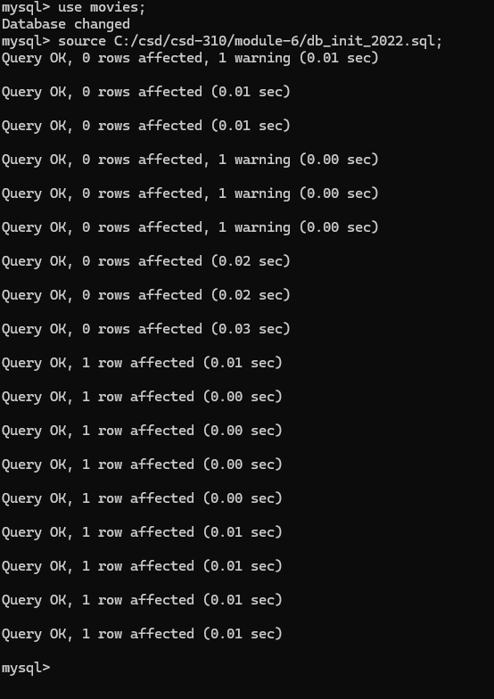

Screenshot 2:

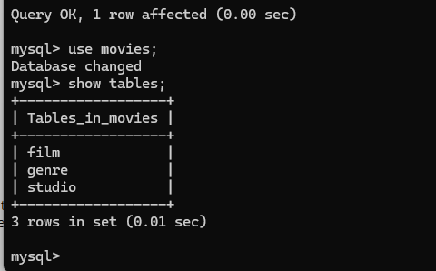

Screenshot 3:

Script running in terminal:
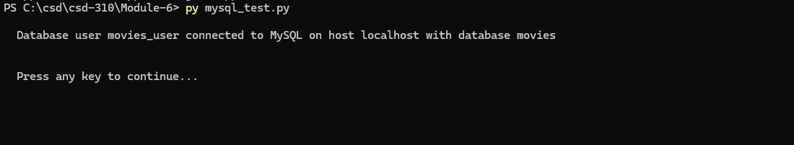

Script running in PyCharm:
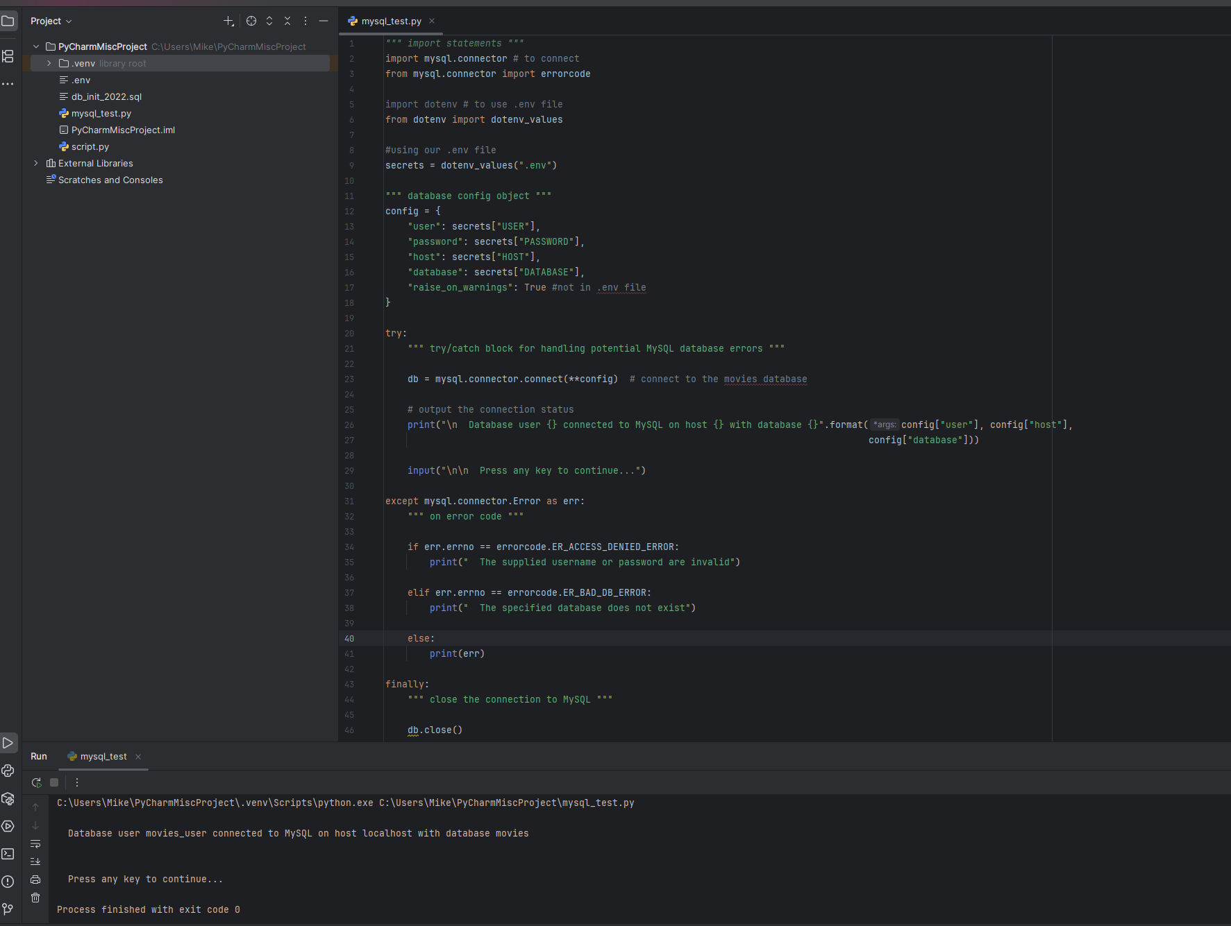

Mikey5007/csd-310: CSD

